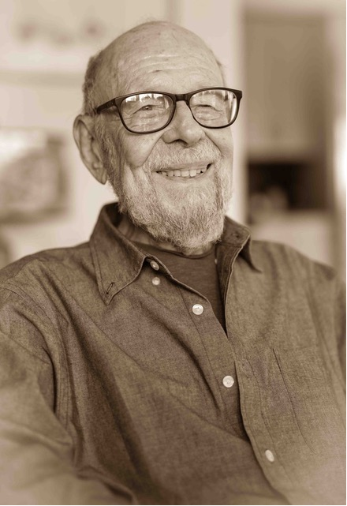

Jerry Levine
Former Chair, California Council for International Trade
Former President, Mentor International
May 17, 1929 - February 8, 2024

Jerry Levine was born in Chicago in 1929, to Jean and Jack Levine. He moved to San Francisco in 1957 to work for Fairchild Semiconductor. San Francisco became his second LOVE, living in the City for the next 67 years. His first LOVE, his wife Toby, were married for 59 years. Toby made Jerry laugh and have fun, always. She loves him thoroughly.

Jerry might be considered a LOVER. He loved San Francisco with a passion…for its beauty, diversity in every way; its “idiosincrasities” (made up word), its unexpectedness. He LOVED his University, MIT. There, he learned be to a citizen of of the world and a LOVER of learning. Being outdoors was another sweet spot and his little spot in the hills of Sonoma county brought him peace and even developed his landscaping skills. That land was thoroughly burned in the Glass Fire of 2020 and is now almost completely rebuilt. Jerry’s ashes will be scattered there celebrating his 95 birthday in May.

Friendships were central to Jerry’s life and he loved his friends dearly…many friendships lasting 60, 70 and 80 years and are not to ever be forgotten.

Mentor International which Jerry conceived of and began in 1963/4 was a great source of pride. It became a "high-tech” consulting firm. Jerry travelled the world advising countries, companies, cities and individuals on ways to develop internationally and promote trade. During his years with Mentor, he was active with the California Council for International Trade (CCIT); and eventually became the Chairman Emeritus. Jerry believed deeply that Fair Trade would make the world a better place for all of us and in recognition of his actions and beliefs, he received the Department of Commerce’s “Peace Through Commerce” Award on November 30, 2011.

Italy: its language, the energy of the Italian people, the beauty of its landscape gave Jerry the desire to learn Italian and spend many happy weeks and months there reveling in its pleasures and working with others to build the now famous Aquario di Genova completed in 1992. Its beauty of design and concept has provided pleasure and education for hundreds of thousands of visitors over the years.

And what did we LOVE about Jerry? He was funny and witty. New places and new people were easily found and accepted by him. He Loved the diversity of life. Jerry loved his newly discovered daughter, Krista, found in 1984. He loved her for her resemblance to Toby. Then, he loved her for her thoughtfulness, wisdom and friendship. Jerry knew how to be a friend…listening carefully, offering hope and help and always being there. He loved a “new game”, a new adventure in life.

One cannot describe the pain and sorrow at his loss; but then, we remember the twinkle in his eye; the mischievous smile and the sorrow and loss drift away into the love we have for Jerry Levine to this day.

